**МИНИСТЕРСТВО ЦИФРОВОГО РАЗВИТИЯ СВЯЗИ И МАССОВЫХ КОММУНИКАЦИЙ**

**Ордена Трудового Красного Знамени**

**Федеральное государственное бюджетное образовательное учреждение высшего образования**

**«Московский технический университет связи и информатики»**

Кафедра «Математическая кибернетика и информационные технологии»

**Отчет по лабораторной работе**

по дисциплине «Введение в информационные технологии» на тему:

**Лабораторная работа №12: Основы выборки SQL**

Выполнил: студент группы БПИ2403

Макаров Вячеслав Васильевич

Проверил:

Москва

2025

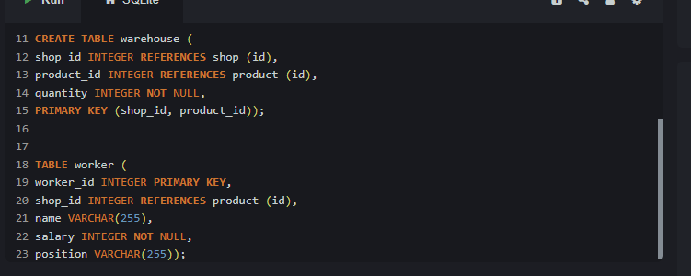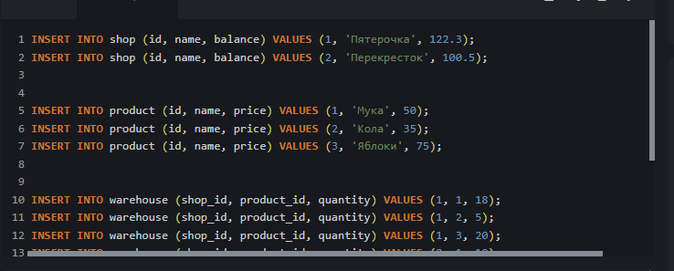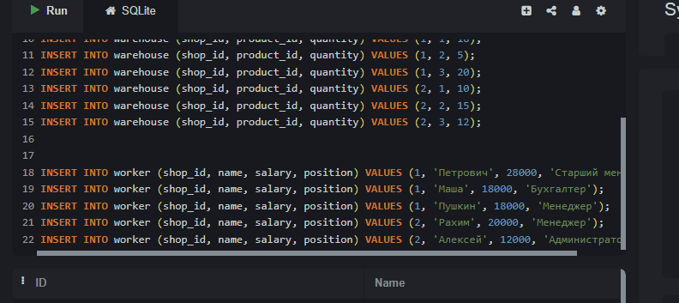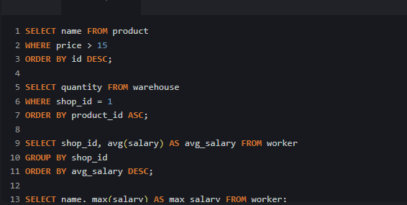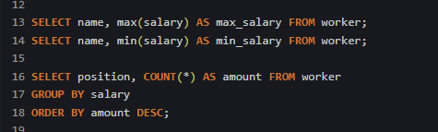

КОД:

CREATE TABLE shop (

id INTEGER PRIMARY KEY,

name VARCHAR(255),

balance FLOAT NOT NULL );

CREATE TABle product (

id INTEGER PRIMARY KEY,

name VARCHAR(255),

price FLOAT NOT NULL)

CREATE TABLE warehouse (

shop_id INTEGER REFERENCES shop (id),

product_id INTEGER REFERENCES product (id),

quantity INTEGER NOT NULL );

CREATE TABLE worker (

worker_id INTEGER PRIMARY KEY,

shop_id INTEGER REFERENCES shop (id),

name VARCHAR(255),

salary INTEGER NOT NULL,

position VARCHAR(255));

INSERT Into shop (id, name, balance) VALUES (1,'Пятерочка', 122.3);

INSERT Into shop (id, name, balance) VALUES (2,'Перекресток', 100.5);

INSERT Into product (name, price) VALUES ('чипсы', 50);

INSERT Into product (name, price) VALUES ('кола', 35);

INSERT Into product (name, price) VALUES ('жвачка', 20);

INSERT Into warehouse (shop_id, product_id, quantity) VALUES (1, 1, 10);

INSERT Into warehouse (shop_id, product_id, quantity) VALUES (1, 2, 5);

INSERT Into warehouse (shop_id, product_id, quantity) VALUES (1, 3, 15);

INSERT Into warehouse (shop_id, product_id, quantity) VALUES (2, 1, 20);

INSERT Into warehouse (shop_id, product_id, quantity) VALUES (2, 2, 10);

INSERT Into warehouse (shop_id, product_id, quantity) VALUES (2, 3, 12);

INSERT Into worker (shop_id, name, salary, position) VALUES (1,'Петрович', 20000, 'Сис админ' );

INSERT Into worker (shop_id, name, salary, position) VALUES (1,'Марина', 10000, 'Уборщица' );

INSERT Into worker (shop_id, name, salary, position) VALUES (1,'Рыжий', 30000, 'Менеджер' );

INSERT Into worker (shop_id, name, salary, position) VALUES (2,'Максим', 18000, 'Мерчик' );

INSERT Into worker (shop_id, name, salary, position) VALUES (2,'Евгений', 32000, 'Директор' );

INSERT Into worker (shop_id, name, salary, position) VALUES (2,'Арсений', 12000, 'Администратор' );

SELECT name FROM product

WHERE price > 15

ORDER BY id desc;

SELECT quantity FROM warehouse

WHERE shop_id = 1

ORDER BY product_id ASC;

SELECT shop_id, avg(salary) AS avg_salary FROM worker

GROUP BY shop_id

ORDER BY avg_salary DESc;

SELECT name, max(salary) as max_salary from worker;

SELECT name, min(salary) as min_salary from worker;

SELECT position, COUNT(*) as amount FROM worker

GROUP BY salary

ORDER BY amount DESC;